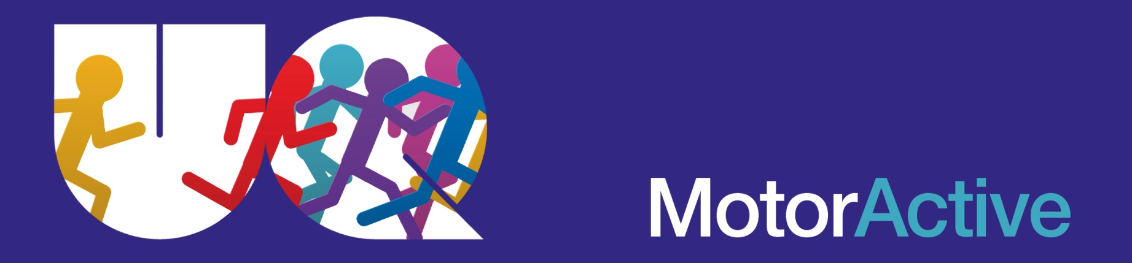

MOTOR ACTIVE 2018 EXPRESSION OF INTEREST FORM Date:
SECTION 1:
Parent/Guardian’s Name:
Phone: Mobile Other
Email Address:

SECTION 2:
Child’s name:
Date of Birth: Male/Female
School Attends (if applicable): Year Level:
Please specify any impairment/disability that may relate to your child. Please include mobility limitations, communication and behavioural considerations, where appropriate:
E.g. My child has ASD and DCD and is able to communicate verbally and follow 1 or 2 step instructions. My child may become anxious when attempting new skills and demonstrate challenging behaviours such as yelling or total withdrawal. OR: My child does not have a diagnosis.

Please describe your child’s functional ability compared with their like age peers. Including any participation in physical activity:
E.g. My child keeps up with their peers in the playground. OR: My child chooses not to participate in active games with his/her peers. OR: My child participates in PE at school at the same level as his/her peers, however I would like my child to do more physical activity. OR: My child seems to be behind in his/her physical activity abilities.

SECTION 2 Continued:
Please provide any other information about your child, which you think may be useful for instructors working with your child in the Motor Active program.

When would you be interested in enrolling your child in the Motor Active program (please highlight preferred options):
- During school terms (1 hour program, once per week for 7 or 8 week blocks)
- During Summer, December/January, school holidays (Once or twice a week for 5 weeks)
- Outside school hours
- During school hours (For preschool program

Privacy Statement
The School of Human Movement and Nutrition Sciences in accordance with The University of Queensland complies with Australian and Queensland privacy laws and guidelines. The School of Human Movement and Nutrition Sciences treats information collected as confidential. Information supplied by you will only be used for the administration or educational purposes of the University or in accordance with a specific consent given by you. The School of Human Movement and Nutrition Sciences will not make available to a third party any personal information supplied by you unless required or permitted by law.
Please email completed form to: hmns.motoractive@uq.edu.au

